Part C
The full analysis is in cox_parametric.R. Diagnostic plots are saved to plots/cox_Schoenfeld.png and plots/cox_Schoenfeld_gg.png.
Sample: N= 7323, D = 2074 (event = 1) and $5249$ are still active at the snapshot date (right-censored). Response: time_days. Censoring indicator: event.
C(a) Cox proportional hazards model
Tie handling
Breslow Efron Exact
purpose_3Earth Observation -0.64072 -0.64144 -0.64192
purpose_3Other -0.59319 -0.59360 -0.59428
users_groupedCivil -0.94590 -0.94683 -0.94760
log_mass -0.17037 -0.17048 -0.17067
log_perigee -3.06794 -3.06866 -3.07004
inclination -0.02110 -0.02110 -0.02113
expected_lifetime_missing -0.38554 -0.38604 -0.38638
..

Max |difference|:
Breslow vs Efron : 0.00092
Breslow vs Exact : 0.00210
Efron vs Exact : 0.00166

The largest disagreement between any two methods is 0.0021 on the log-hazard scale three orders of magnitude smaller than the smallest standard error in the model (~0.02 for log_mass/inclination), so on the HR scale you'd see differences in the 3rd–4th decimal at most. No coefficient changes sign, no inference changes (significance, ranking, magnitude all preserved).
To report: Survival times are recorded in days, so the data contain a moderate number of tied event times. Refitting the selected Cox model with Breslow's, Efron's and the exact partial likelihood gives near-identical coefficients (max absolute difference 0.0021 on the log-hazard scale, < 0.5 % of the smallest SE). Significance and effect direction are unchanged in every covariate. We therefore report the Breslow fit
Model building
We start from a candidate set chosen to avoid multi-collinearity:
- perigee vs apogee r = 0.83 (raw) / 0.98 (log) → keep only log_perigee (lowest altitude drives drag);
- period vs apogee r = 0.97 (Kepler's third law) → drop period;
- country_grouped vs launch_vehicle_group Cramér's V = 0.67 (well above the 0.5 "strong association" threshold; 5 vs 15 levels) → keep only country_grouped;
- expected_lifetime_missing kept as missingness flag.

We start from a candidate set chosen to avoid the obvious collinearities flagged in Part A (the descriptive analysis):
- perigee and apogee are almost perfectly correlated → keep only log_perigee;
- country_grouped and launch_vehicle_group are strongly associated → keep only country_grouped;
- period is a deterministic function of apogee+perigee → drop;
- expected_lifetime_missing kept as missingness flag.
Stepwise AIC (is both directions) was run with purpose_3 forced into the lower scope. Only orbit_altitude_class was dropped: log_perigee already explains altitude almost completely.
The selected model is
coxph(Surv(time_days, event) ~ purpose_3 + country_grouped + users_grouped +
orbit_geometry_type + log_mass + log_perigee +
inclination + expected_lifetime +
expected_lifetime_missing,
data = Satellite, ties = "breslow")
AIC: 28215. Concordance: 0.901 (se 0.003): extremely high, almost entirely driven by log_perigee (low perigee = strong atmospheric drag).
Hazard ratios and 95 % CIs
Reference levels: purpose_3 = Communications, country_grouped = US, users_grouped = Commercial, orbit_geometry_type = Inclined.
Covariate | HR | 95 % CI | p
purpose_3 = Earth Observation | 0.527 | (0.456, 0.609) | <1e-16
purpose_3 = Other | 0.553 | (0.461, 0.663) | 1.6e-10
country = China | 0.971 | (0.781, 1.206) | 0.79
country = Europe | 1.136 | (0.918, 1.406) | 0.24
country = Russia | 1.299 | (0.750, 2.251) | 0.35
country = Other | 1.361 | (1.120, 1.654) | 0.0019
users = Civil | 0.388 | (0.304, 0.497) | 6.8e-14
users = Government | 0.466 | (0.367, 0.591) | 3.3e-10
users = Military | 0.907 | (0.682, 1.205) | 0.50
users = Mixed | 0.475 | (0.320, 0.704) | 2e-04
orbit_geom = Polar | 1.765 | (1.262, 2.468) | 9e-04
orbit_geom = Sun-Sync | 2.910 | (2.032, 4.168) | 5.7e-09
orbit_geom = Other | 0.754 | (0.472, 1.204) | 0.24
log_mass | 0.843 | (0.810, 0.878) | <1e-16
log_perigee | 0.047 | (0.041, 0.053) | <1e-16
inclination | 0.979 | (0.972, 0.986) | 8e-09
expected_lifetime | 0.917 | (0.852, 0.986) | 0.019
expected_lifetime_missing | 0.680 | (0.615, 0.753) | 9e-14

Interpretation of the relative risks
- log_perigee dominates: a one-log-unit increase (≈ ×2.7 in km) reduces the instantaneous decay hazard by a factor 0.047 (HR = 1/21.6). Satellites in low orbits are pulled down by the residual atmosphere; raising the perigee removes that drag.
- log_mass: heavier satellites have lower hazard (HR 0.84 per log-kg). Heavy birds resist drag better and tend to be designed for longer missions.
- inclination and expected_lifetime: small but significant protective effects.
- expected_lifetime_missing acts as a risk-marker for younger / small-cubesat-type missions; its protective sign just reflects that records without a published lifetime are typically modern, in higher orbits.
- Categorical results: relative to the commercial user reference, Civil/Government/Mixed satellites have ~50–60 % lower hazard. Polar and Sun-Synchronous orbits decay faster than generic inclined orbits even conditionally on perigee — likely because Sun-Sync satellites cluster at the lower end of the LEO range. Country effects are weak; only the heterogeneous "Other" group is materially significant.
Test for the categorical Part-B variable
Partial likelihood-ratio test (model with vs without purpose_3):
Model | log-lik | Δχ² | df | p
without purpose_3 | −14 128
with purpose_3 | −14 090 | 76.75 | 2 | < 2.2e-16

The Wald linear-hypothesis test gives χ² = 80.7, df = 2, p < 2.2e-16. So purpose_3 is highly significant, exactly the same qualitative conclusion as the log-rank test in Part B (χ² = 85.4, p < 2e-16).
But notice the direction reverses: in Part B the unadjusted KM curves showed Earth Observation as the shortest-lived group. Here, conditionally on perigee/mass/orbit, Earth Observation has a hazard that is roughly half of Communications. This is a clear case of confounding by altitude: EO satellites cluster in low orbits, so most of their apparent excess decay is absorbed by log_perigee once it enters the model.
Proportional-hazards check
Schoenfeld global test (cox.zph):
Variable | χ² | df | p
purpose_3 | 137.9 | 2 | <2e-16
country_grouped | 53.6 | 4 | 6.3e-11
users_grouped | 88.8 | 4 | <2e-16
orbit_geometry_type | 180.6 | 3 | <2e-16
log_mass | 93.6 | 1 | <2e-16
log_perigee | 12.2 | 1 | 4.9e-04
inclination | 103.3 | 1 | <2e-16
expected_lifetime | 26.4 | 1 | 2.9e-07
expected_lifetime_missing | 1.7 | 1 | 0.19
GLOBAL | 334.0 | 18 | <2e-16

The test rejects PH globally and for almost every covariate. Two caveats are worth keeping in mind:
- The Schoenfeld test is very sensitive at N= 7323 D = 2074 even tiny deviations from PH are detected.
- Inspecting the smoothed Schoenfeld residual plots (plots/cox_Schoenfeld_gg.png), the Beta(t) curves are largely flat inside their 95 % bands for most variables; the strongest non-PH pattern is a gradual time-trend in inclination and orbit_geometry_type

- Global:
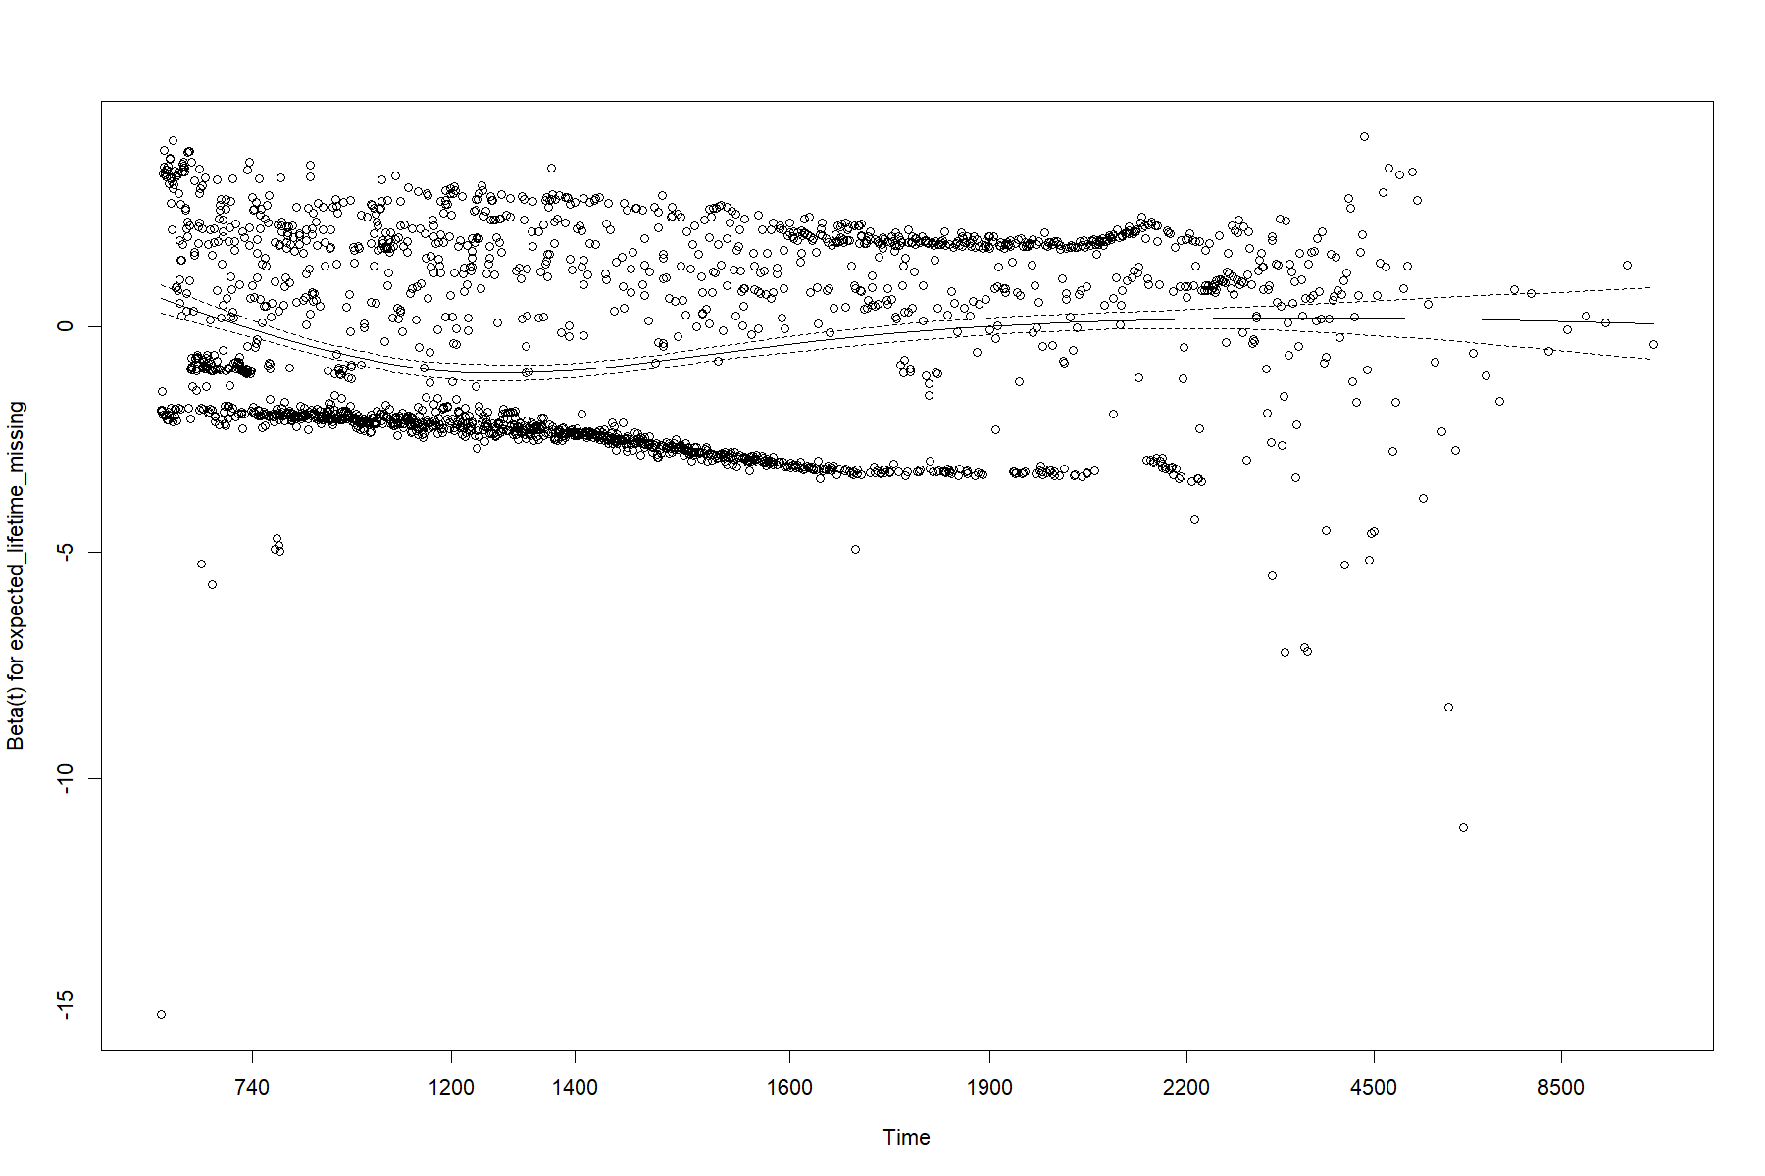
- Individual: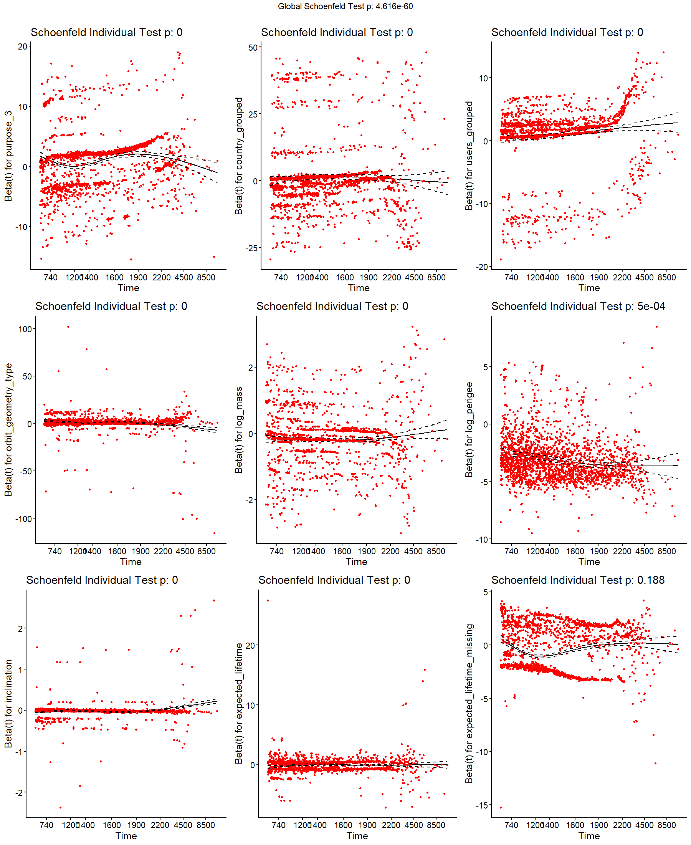
So the PH assumption is statistically violated but the violations are small in magnitude. The hazard ratios above should still be read as time-averaged effects rather than instantaneous ratios. Fixes (stratification on orbit_geometry_type, time-varying coefficients, or switching to a non-PH model) would be the next steps; in part C(b) we follow the third route via a parametric model that does not require PH.

C(b) Parametric regression
Following the assignment, we re-fit the same set of covariates as in the selected Cox model, this time as parametric AFT models (survreg).
Distribution choice
Distribution | AIC
weibull | 33 554.6
exponential | 35 257.9
lognormal | 34 022.3
loglogistic | 33 414.2

The log-logistic model has the lowest AIC. This is intuitively consistent with the satellite hazard physics: the failure rate first rises (early-life infant-mortality + first crossings through atmospheric drag) and then falls for the survivors, exactly the unimodal hazard the log-logistic encodes (and which Weibull's monotone hazard cannot).
Coefficients
The log-linear representation of survreg is
$$log⁡T_{i}=μ+γ^{⊤}x_{i}+σW_{i},$$with $\overset{^}{μ}=-0.408$ and $\overset{^}{σ}=e^{-1.294}=0.274$.
The AFT representation is $S_{i}(t)=S_{0}(exp⁡(θ^{⊤}x_{i})t)$ with $θ=-γ$. A positive $\overset{^}{γ}$ (= negative $\overset{^}{θ}$) means longer survival / acceleration factor below 1.
Covariate | $\overset{^}{γ}$ (log-linear) | 95 % CI | $\overset{^}{θ}$ (AFT) | AF = $e^{\overset{^}{θ}}$ | 95 % CI for AF
(Intercept) | −0.408 | (−0.781, −0.034) | 0.408 | 1.503 | (1.035, 2.183)
purpose_3 = Earth Observation | 0.178 | ( 0.112, 0.243) | −0.178 | 0.837 | (0.784, 0.894)
purpose_3 = Other | 0.162 | ( 0.071, 0.253) | −0.162 | 0.850 | (0.777, 0.931)
country = China | −0.014 | (−0.114, 0.086) | 0.014 | 1.014 | (0.918, 1.120)
country = Europe | −0.119 | (−0.217, −0.021) | 0.119 | 1.126 | (1.021, 1.242)
country = Russia | −0.099 | (−0.337, 0.139) | 0.099 | 1.104 | (0.870, 1.401)
country = Other | −0.041 | (−0.129, 0.047) | 0.041 | 1.042 | (0.954, 1.137)
users = Civil | 0.286 | (0.162, 0.409) | −0.286 | 0.752 | (0.664, 0.851)
users = Government | 0.325 | (0.214, 0.435) | −0.325 | 0.723 | (0.647, 0.807)
users = Military | 0.006 | (−0.122, 0.135) | −0.006 | 0.993 | (0.874, 1.129)
users = Mixed | 0.292 | (0.119, 0.465) | −0.292 | 0.747 | (0.628, 0.888)
orbit_geom = Polar | −0.272 | (−0.407, −0.136) | 0.272 | 1.312 | (1.146, 1.503)
orbit_geom = Sun-Sync | −0.545 | (−0.704, −0.386) | 0.545 | 1.725 | (1.471, 2.022)
orbit_geom = Other | 0.146 | (−0.063, 0.354) | −0.146 | 0.864 | (0.702, 1.065)
log_mass | 0.076 | (0.057, 0.094) | −0.076 | 0.927 | (0.910, 0.945)
log_perigee | 1.249 | (1.191, 1.306) | −1.249 | 0.287 | (0.271, 0.304)
inclination | 0.012 | (0.009, 0.015) | −0.012 | 0.989 | (0.986, 0.991)
expected_lifetime | 0.064 | (0.023, 0.105) | −0.064 | 0.938 | (0.900, 0.977)
expected_lifetime_missing | 0.119 | (0.072, 0.166) | −0.119 | 0.888 | (0.847, 0.930)

Reading example: an Earth-Observation satellite has $θ=-0.178$, so its time runs at AF = 0.84 of a Communications satellite — equivalently, its lifetime is stretched by a factor $1/0.84≈1.19$ at every quantile. A one-log-unit rise in perigee multiplies survival times by $1/0.287≈3.5$.
Comparison with the Cox model and Part B
The picture is the same qualitatively for every covariate:
Direction in Cox (HR<1 = protective) | Direction in AFT (AF<1 = protective)
EO, Other (purpose): protective | same
Civil/Government/Mixed users: protective | same
Polar, Sun-Sync: risky | same
log_mass, log_perigee, inclination, expected_lifetime: protective | same
Country effects mostly null | same

Magnitudes are not directly comparable (HRs vs AFs) but the rankings agree. In particular, both models tell the same story relative to Part B:
- Part B (purpose only): Earth Observation looks worse.
- Part C (purpose adjusted for orbit/mass): Earth Observation looks better.
The disagreement between the marginal Part-B picture and the adjusted Part-C picture is the mechanism: EO satellites are over-represented in LEO, and the adjustment for log_perigee redistributes the blame from "purpose" to "orbit". Both models and the nonparametric Part B agree that satellite purpose does matter (highly significant in all three), but the direction of the conditional effect is the opposite of the marginal one. That is exactly the kind of insight that justifies moving from Part B to a regression model in Part C.

